November 28, 2024

New Delhi, India



USER GUIDE

*EmpowerU Cash Transfer*



TABLE OF CONTENTS

CHAPTER 1 – CASH TRANSFER 3

1.1 ELIGIBLE 5

1.2 VERIFICATION – PROGRAM COORDINATOR 7

1.3 APPROVAL – PROGRAM MANAGER 11

1.4 PAYMENT – TREASURY 15

# CHAPTER 1 – CASH TRANSFER

The Cash Transfer module is developed to manage and track the **cash transfer** flow of registered households and its approvals. Click on the **cash transfer** option from the **Burger** menu to access this module. This module is program cycle, installment, and cash transfer status-driven. The cash transfer contains four steps for each installment –

1. Eligible
2. Verification
3. Approval
4. Payment

Each cash transfer step has to go through an approval process by authorized users to move forward with the next step. The below table explains the actions to be performed in each cash transfer step by the authorized users -

|  |  |  |  |  |  |  |  |  |  |  |  |
| --- | --- | --- | --- | --- | --- | --- | --- | --- | --- | --- | --- |
|  | Eligible | | Verification | | | Approval | | | Payment | | |
| # | Export | Send Notification | Export | Import | Verify All | Export | Import | Verify All | Export | Import | Bank Payment |
| Administrator | **Checkmark** | **Checkmark** | **Checkmark** | **Checkmark** | **Checkmark** | **Checkmark** | **Checkmark** | **Checkmark** | **Checkmark** | **Checkmark** | **Checkmark** |
| Program Officer | **Checkmark** | **Checkmark** | **Checkmark** |  |  | **Checkmark** |  |  |  |  |  |
| Program Coordinator | **Checkmark** |  | Checkmark | Checkmark | **Checkmark** | Checkmark | ─ |  | Checkmark | ─ | ─ |
| Program Manager | Checkmark |  | Checkmark | ─ |  | Checkmark | Checkmark | Checkmark | Checkmark | ─ | ─ |
| Treasury | Checkmark |  | Checkmark | ─ |  | Checkmark | ─ |  | Checkmark | Checkmark | Checkmark |

## **1.1 ELIGIBLE**

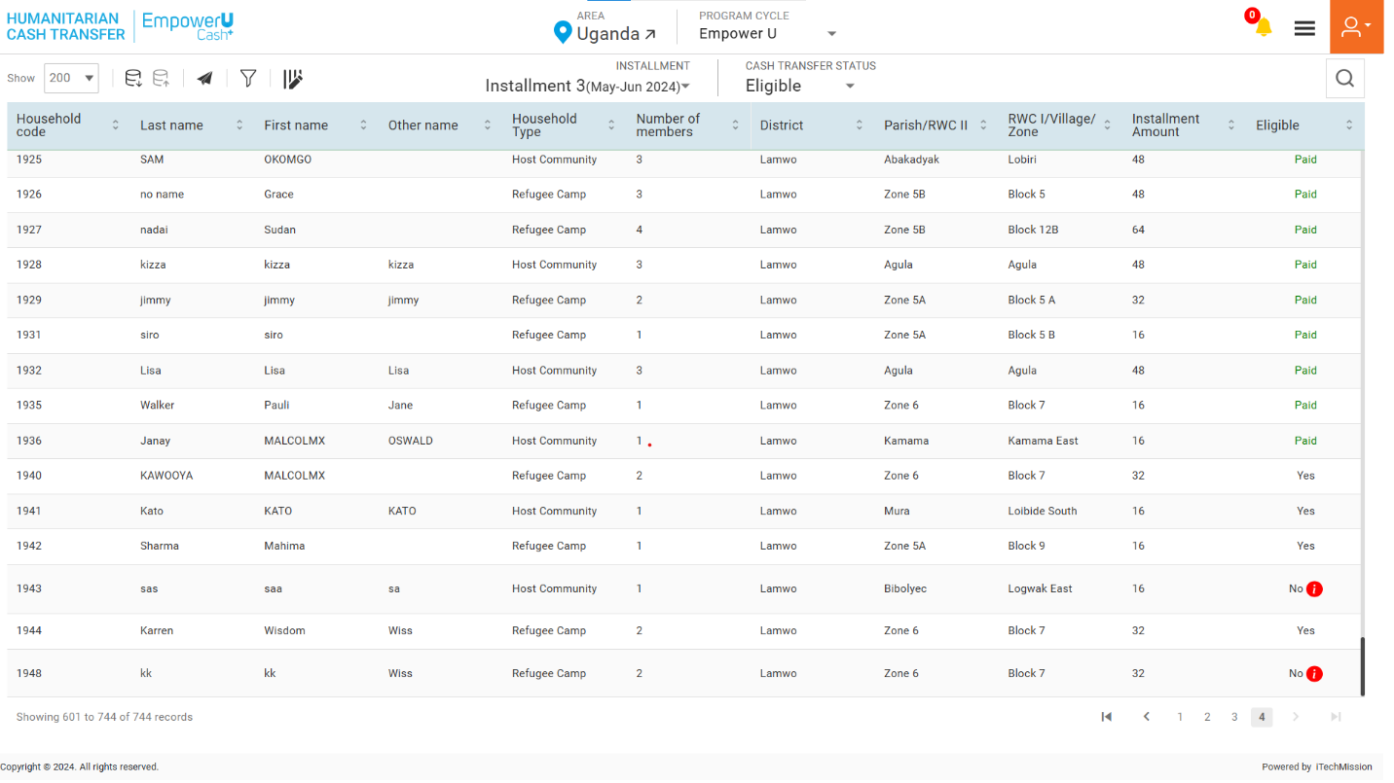The first Cash Transfer step allows you to view the household’ eligibility list (see below figure). You also have the option to view the reason for not eligibility of households.

*Hover over the Information button from the Eligible column to view the reason for the eligible status of the selected household to be No.*

****Click on the **Send Notification** button in order to notify the program coordinator to start the next step of the Cash Transfer process.

*“Only the households with eligibility status Yes will be moved to next cash transfer step i.e. Verification.”*

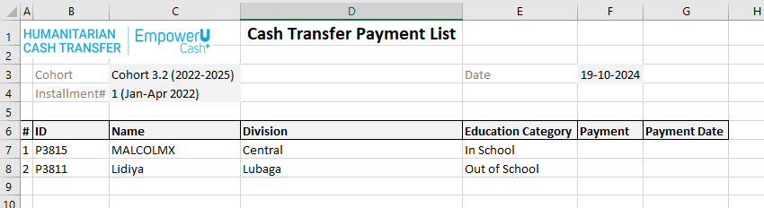Click on the **Export** button to download to download the household's eligibility data available in the database (See the below figure).

*The list is exported in the CSV (Comma Separated Value) file format.*

## **1.2 VERIFICATION – PROGRAM COORDINATOR**

In this step of the Cash Transfer process, the eligible household have to be verified by the Admin or the Program Coordinator to move to the next step of the cash transfer process. **The Program Coordinator** will receive notification to start verification of the eligible households.

Login as program coordinator and click on the notification button to view the received notification. (see the below figure)

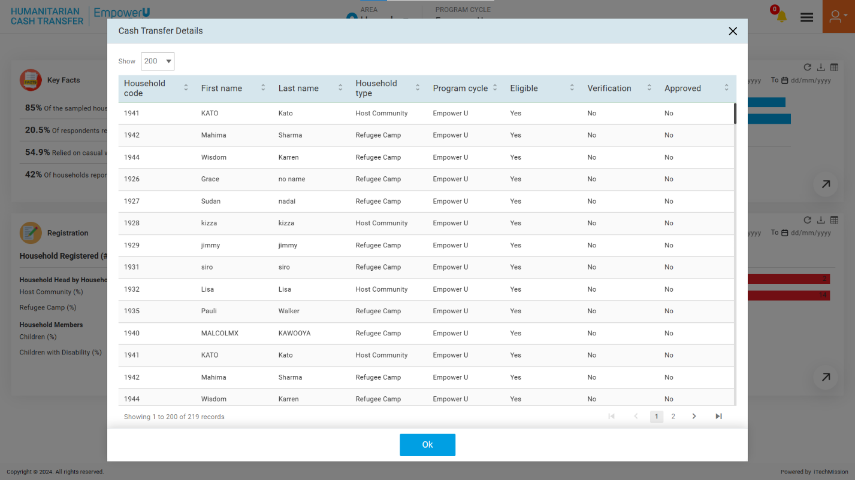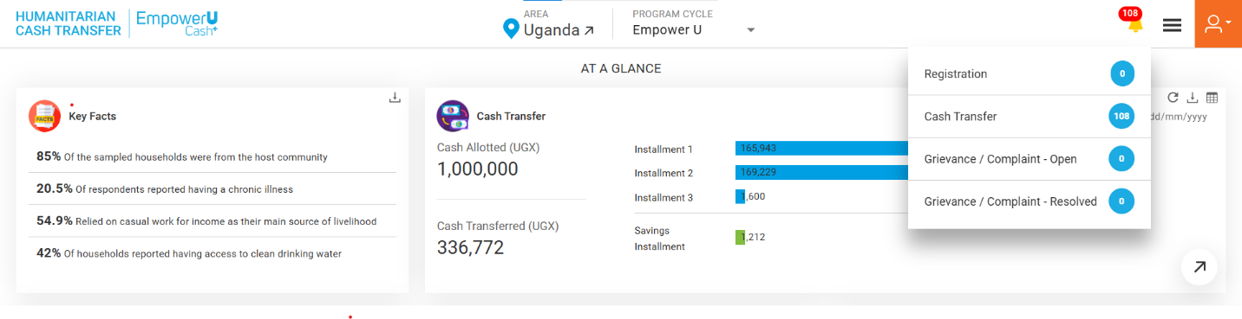

To approve verification, navigate to the Cash Transfer module. Click on the **Cash Transfer Status** dropdown available on the navigation panel, and select the Verification option.

Click on the **Select** dropdown and select one of the options from **Yes or No** to complete the verification of the selected **Household**. If clicked Yes, the household is verified and will be moved to the next step of the cash transfer process. (see the below figure)

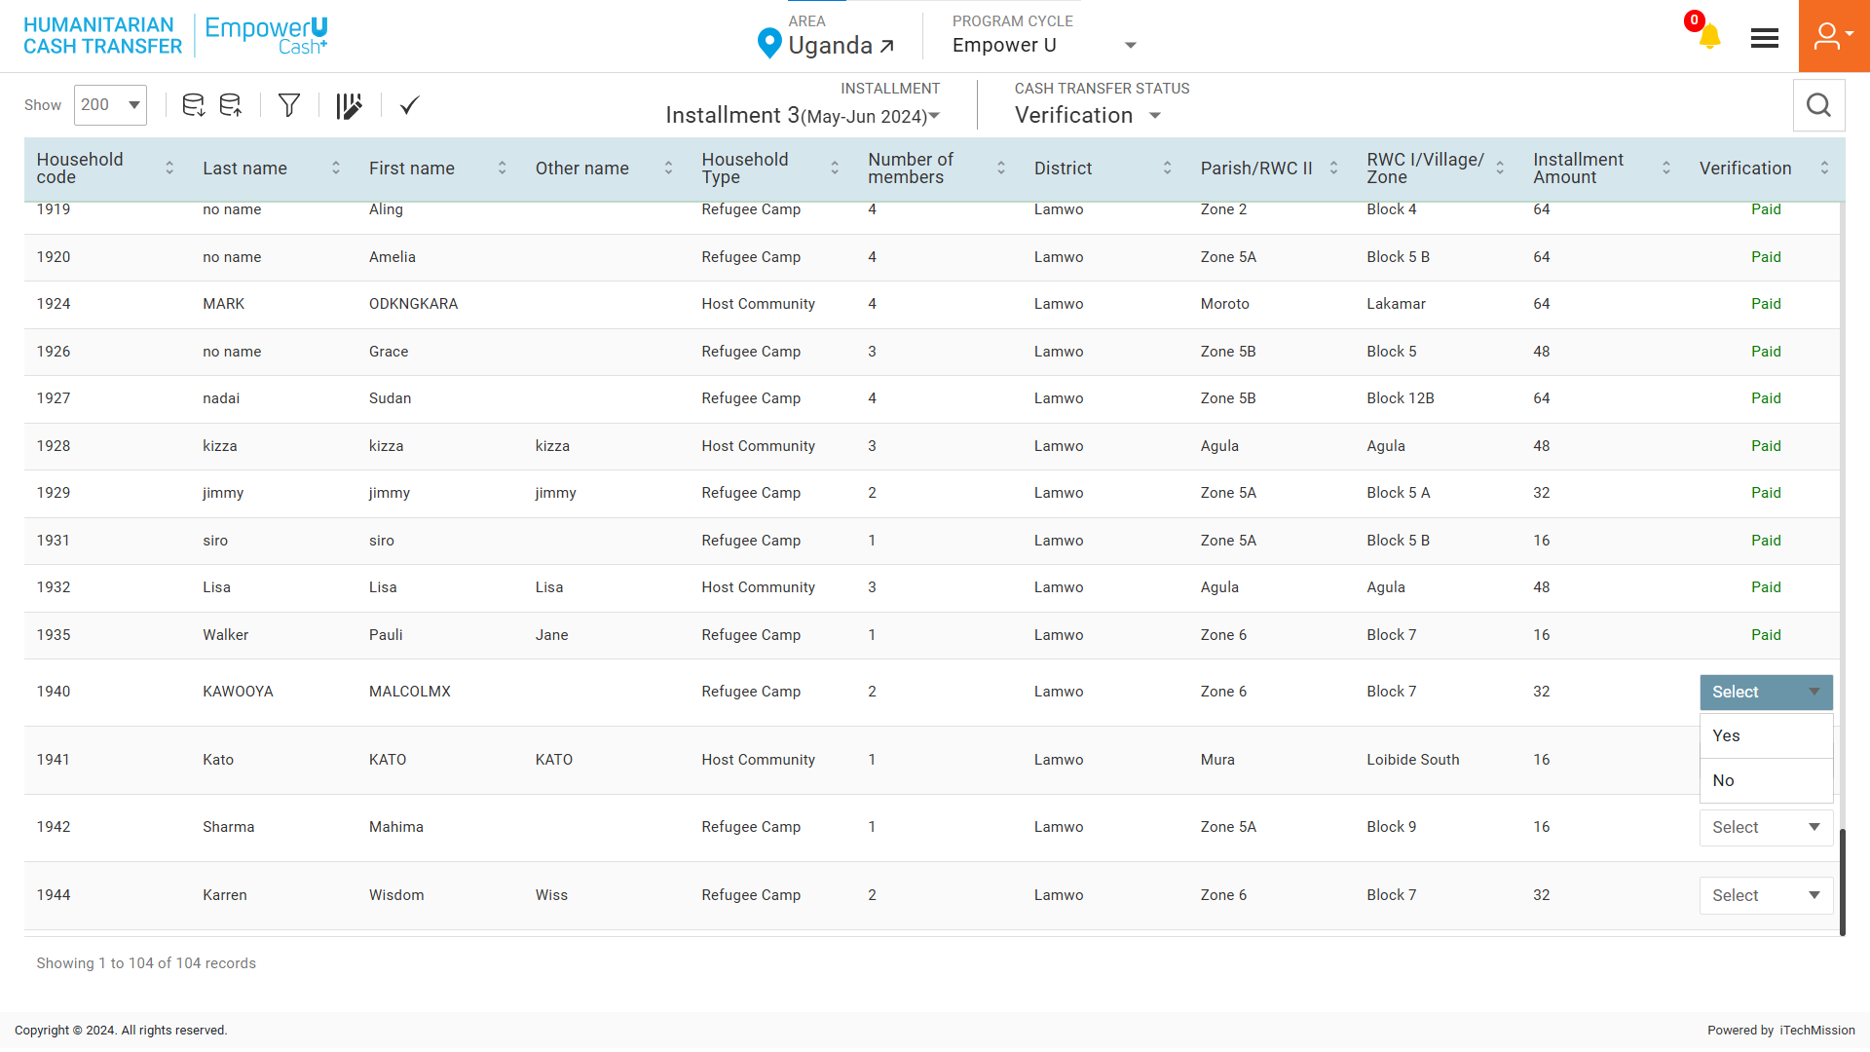

Click on the **Verify All** button from the navigation bar to complete the verification of all the households.

Click on the **Export** button to download the verification template structure in CSV file format (see below figure)

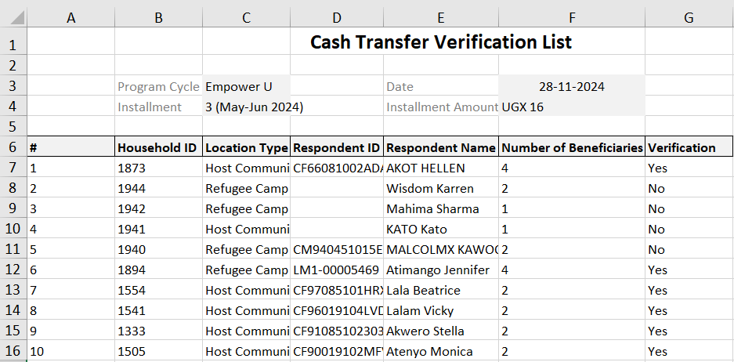

To Complete the verification process of bulk household at once, you can edit and the downloaded verification file and enter Yes or No in the Verification column then upload the file by clicking on the **Import** button (see figure below). 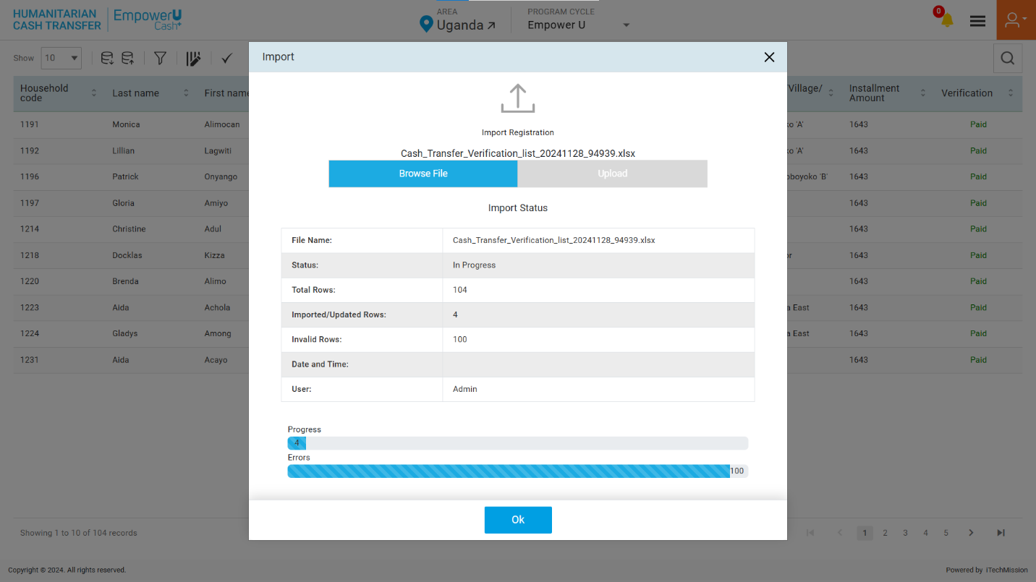

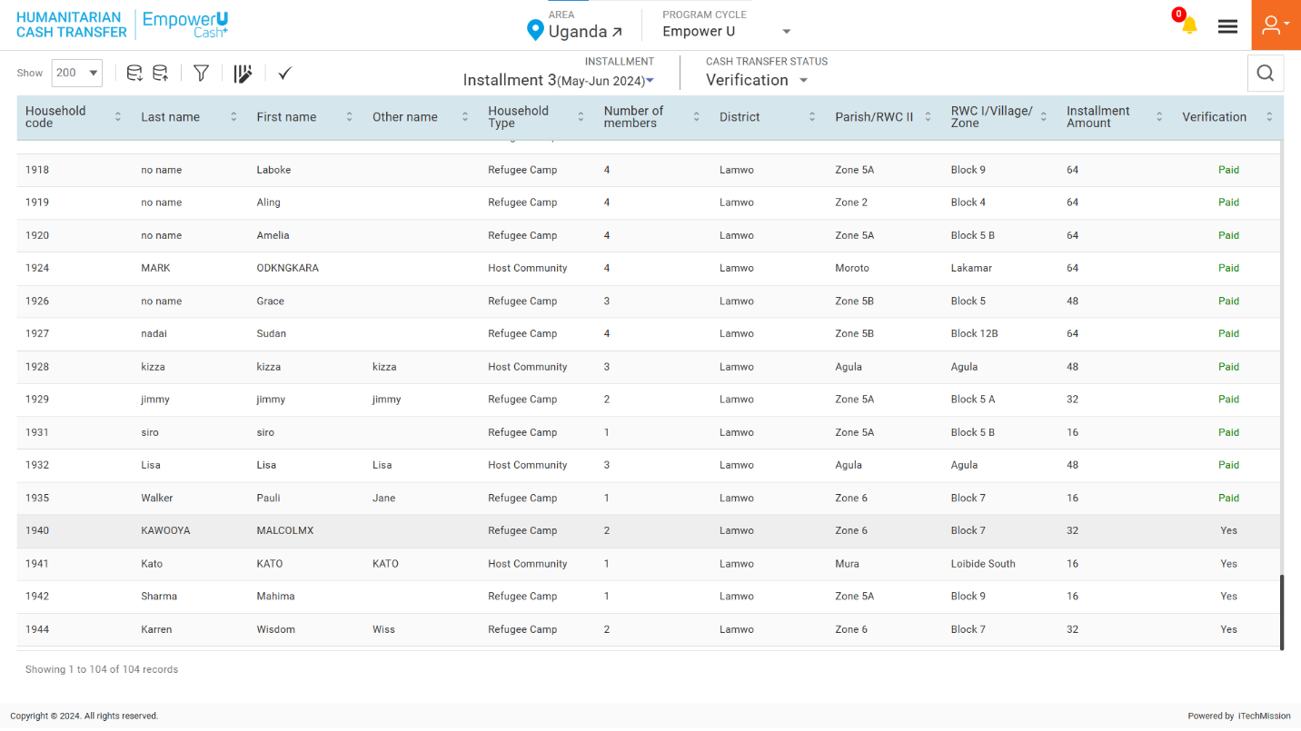

*“Only the households with verification status as Yes will be moved to next cash*

## **1.3 APPROVAL – PROGRAM MANAGER**

In this step of the Cash Transfer process, the eligible household have to be verified by the Admin or the Program Coordinator to move to the next step of the cash transfer process. **The Program Manager** will receive notification to start verification of the eligible households.

Login as program coordinator and click on the notification button to view the received notification. (see the below figure)

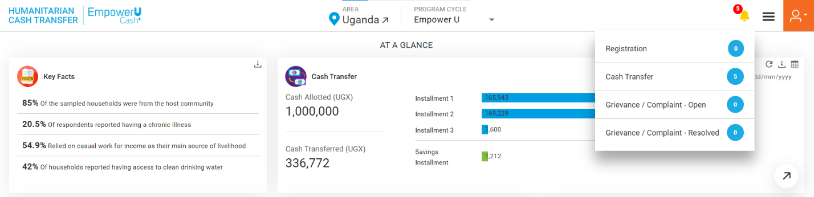



To approve verification, navigate to the Cash Transfer module. Click on the **Cash Transfer Status** dropdown available on the navigation panel, and select the Verification option.

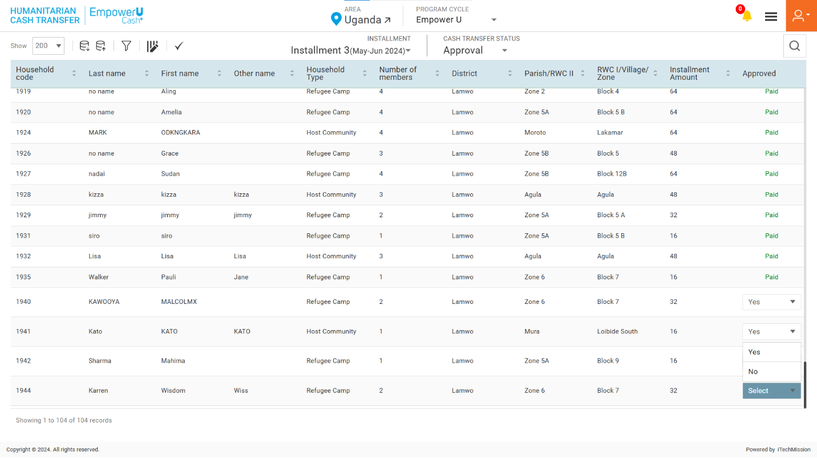Click on the **Select** dropdown and select one of the options from **Yes or No** to complete the verification of the selected **Household**. If clicked Yes, the household is verified and will be moved to the next step of the cash transfer process. (see the below figure)

Click on the **Verify All** button from the navigation bar to complete the verification of all the households.

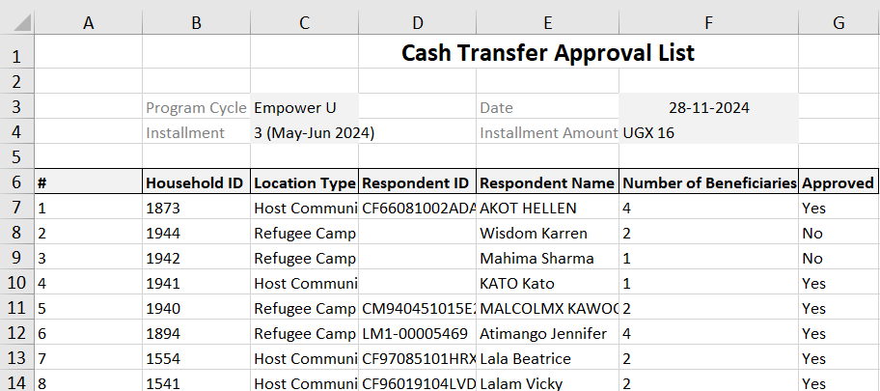Click on the **Export** button to download the verification template structure in CSV file format (see below figure)

To Complete the verification process of bulk household at once, you can edit and the downloaded verification file and enter Yes or No in the Verification column then upload the file by clicking on the **Import** button (see figure below). 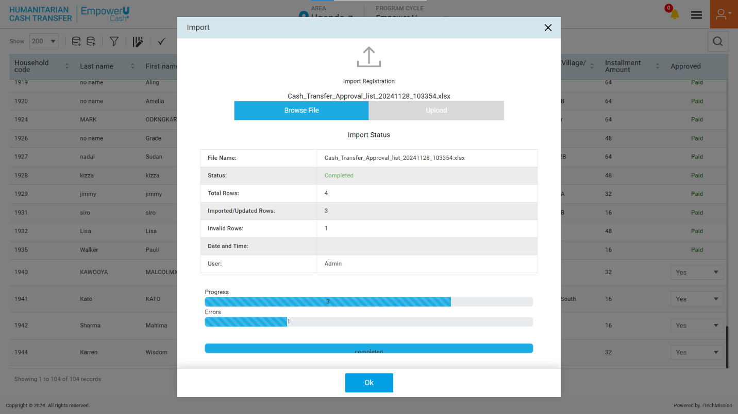

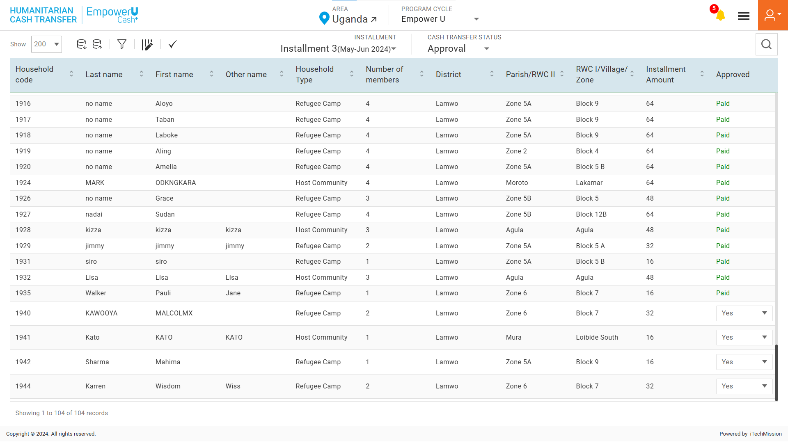

*“Only the households with approval status as Yes will be moved to next cash transfer step i.e., Payment.”*

## **1.4 PAYMENT – TREASURY**

In this step of the Cash Transfer process, the eligible household has to be verified by the Admin or the Treasury to move to the next step of the cash transfer process. **The Treasury** will receive a notification to start verification of the eligible households.

Login as program coordinator and click on the notification button to view the received notification. (see the below figure)

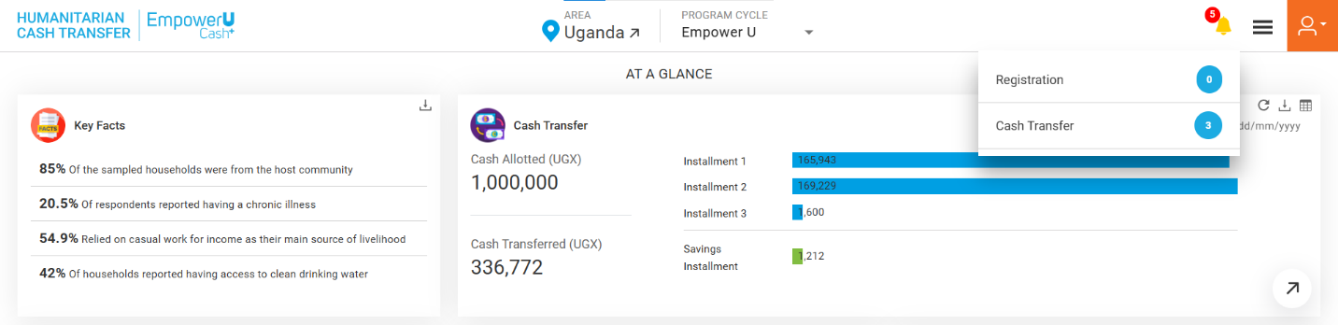

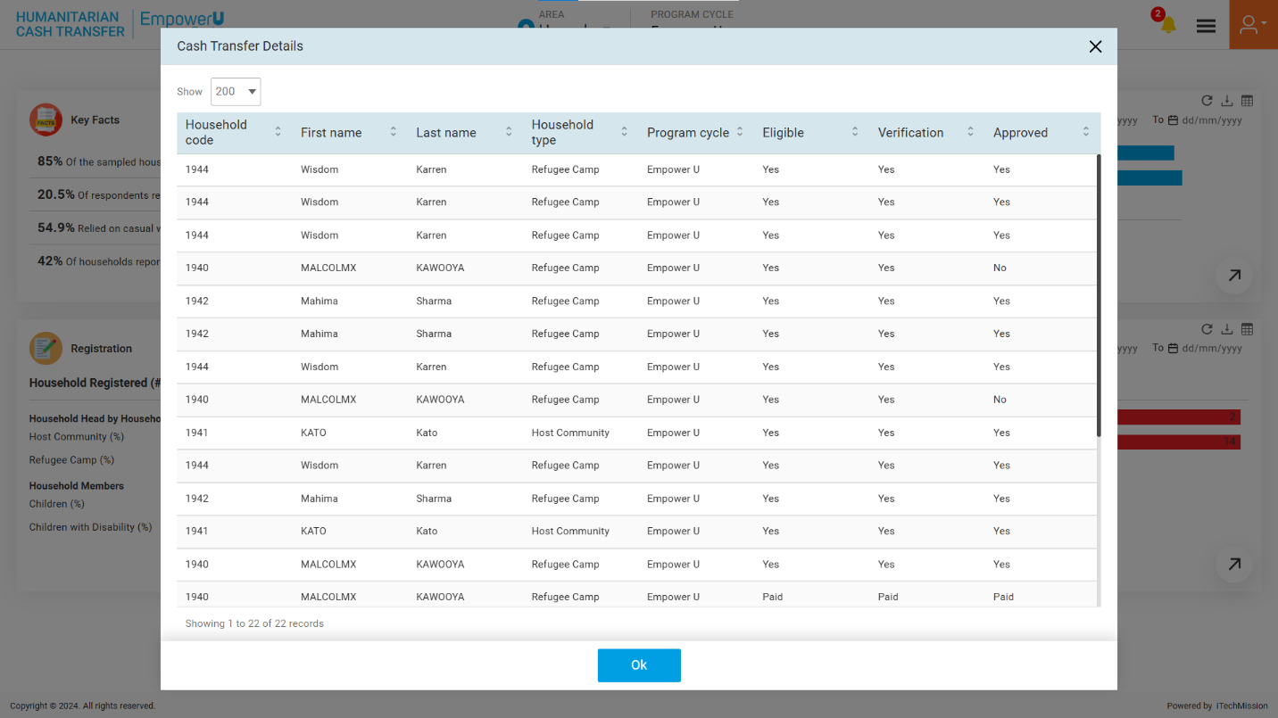

Click on the **Bank Payment list** button to download the list of households whose payment status is not available or is not paid (see the below figure)

To make a payment, navigate to the Cash Transfer module. Click on the **Cash Transfer Status** dropdown available on the navigation panel, and select the Payment option.

Click on the **Select** dropdown and select the Pay option to add payment details of the selected **Household**. If clicked Paid, enter the Date of the payment and the Household status will appear as Paid. (see the below figure)

Click on the **Export** button to download the verification template structure in CSV file format .

You can download the payment list of all households and not-paid households available in the database (see below figure).

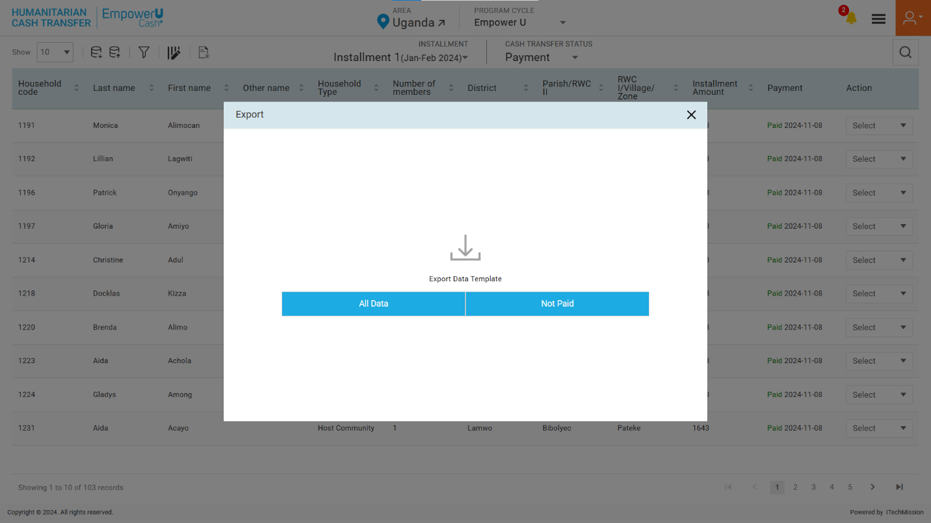

By clicking on the **All-Data** button, you can download a list of all household available with their payment status in CSV format (see below figure).

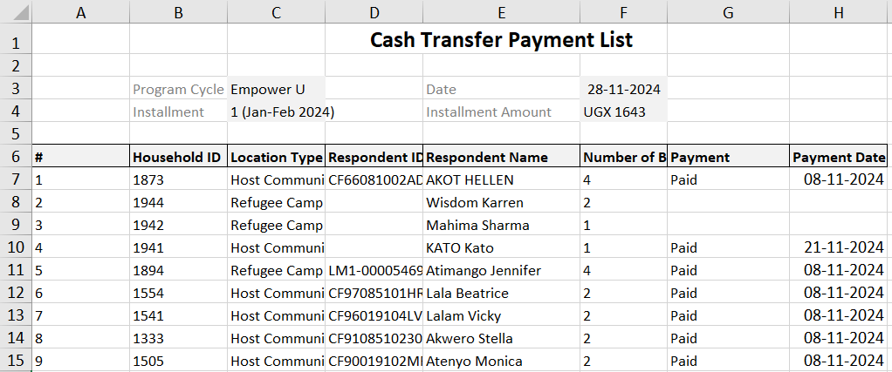

By clicking on the **Not Paid** button, you can download the list of household whose payment status is not available or is not paid in CSV format (see below figure).

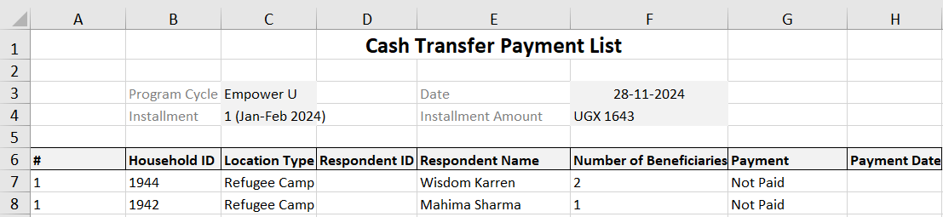

To update the payment status of bulk households at once, you can edit the downloaded payment file and upload the file after entering all required details by clicking on the **Import** option (see figure below).

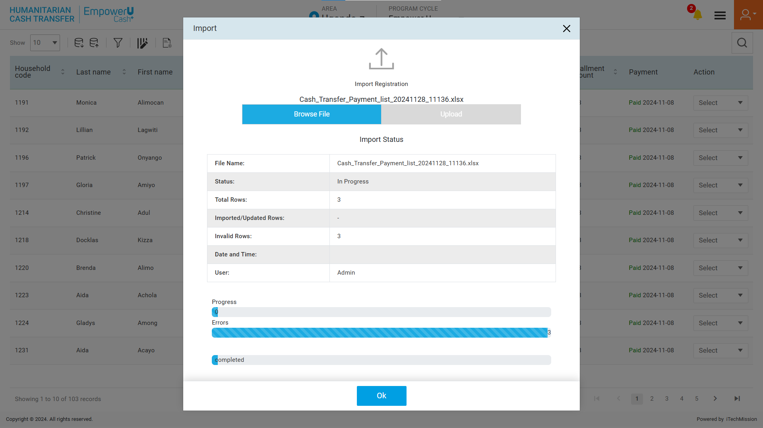

To update payment status, navigate to **Cash Transfer** module and select **Payment** from cash transfer status dropdown. Click to select Pay from the Payment column to update the payment status of selected household (see below figure).

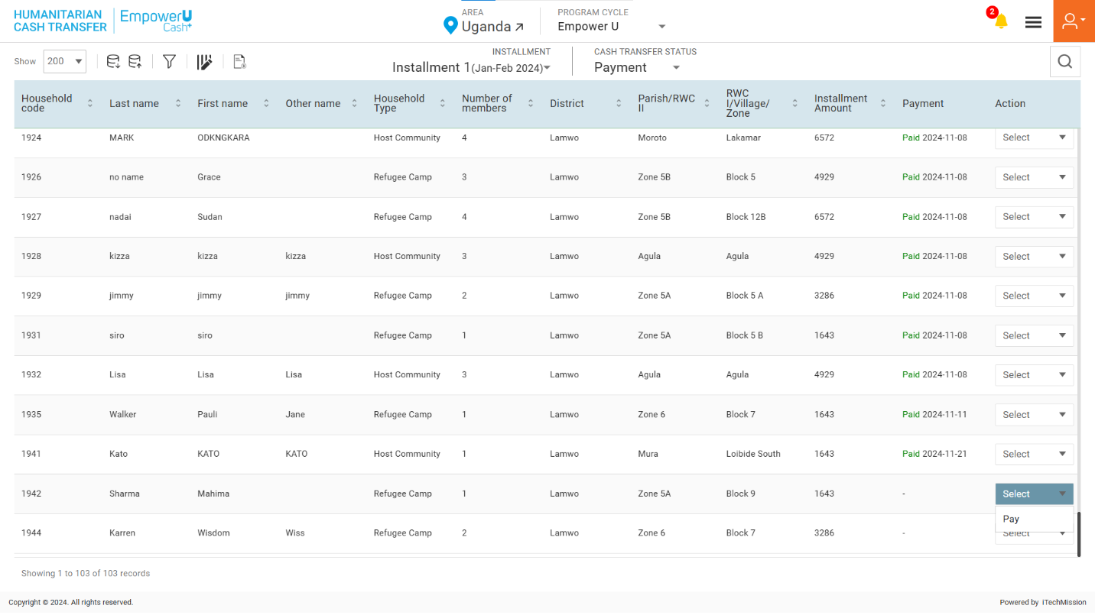

A payment popup window appears, click to select Yes/No in the payment status dropdown. If clicked **Yes**, an additional date field will be added to enter the payment date (see below figures). After entering all details, click on OK to save payment details.

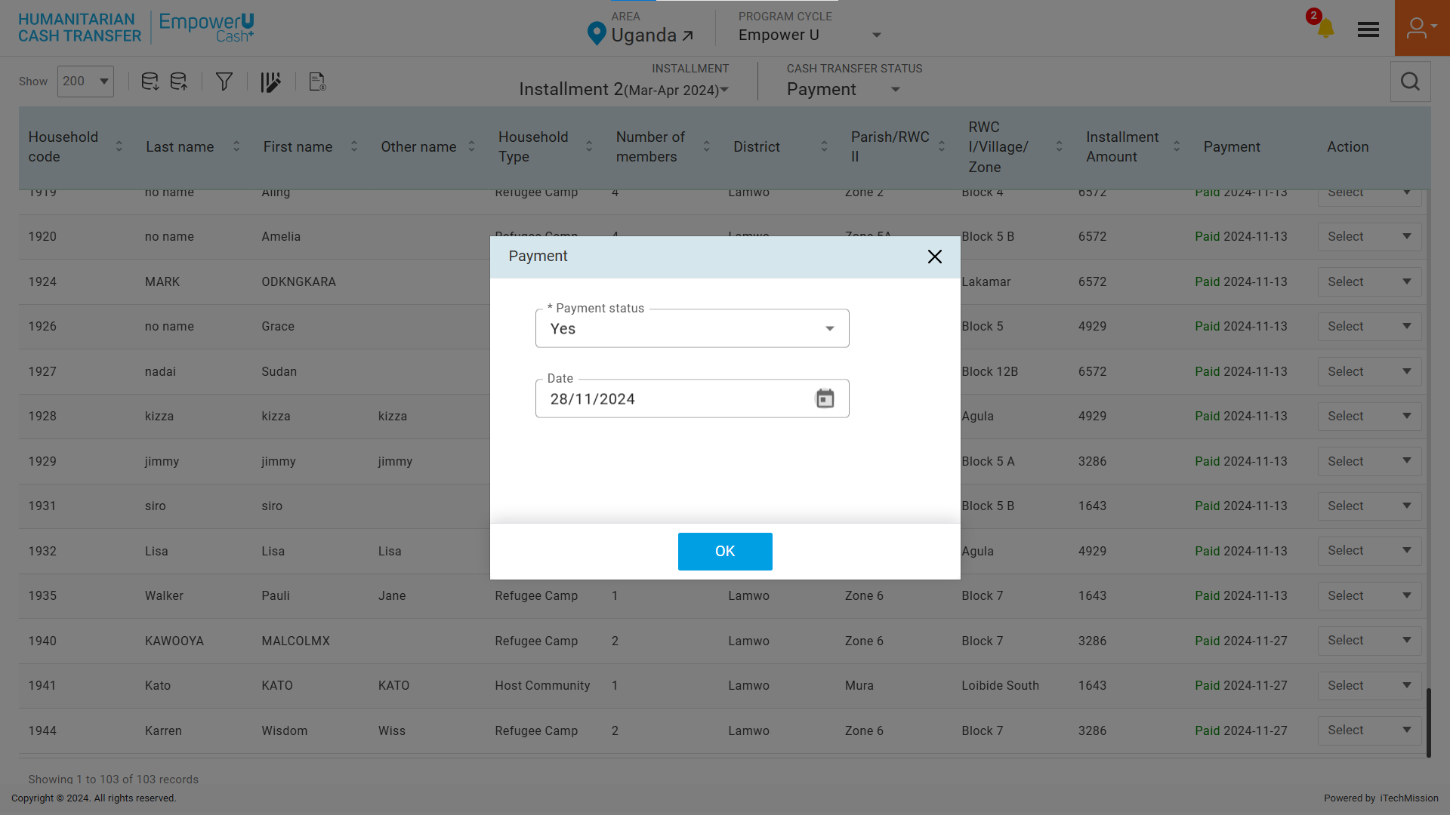

END OF THE DOCUMENT 